**JENKINS – BUILD – DEPLOYMENT**

**STEPS:**

1. Create one maven project in spring boot and add junit test cases.

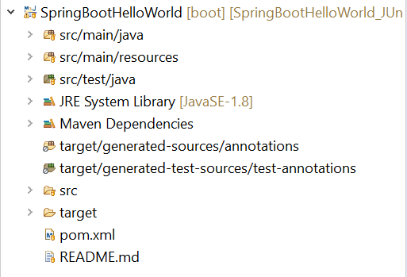

1. Login Jenkins:

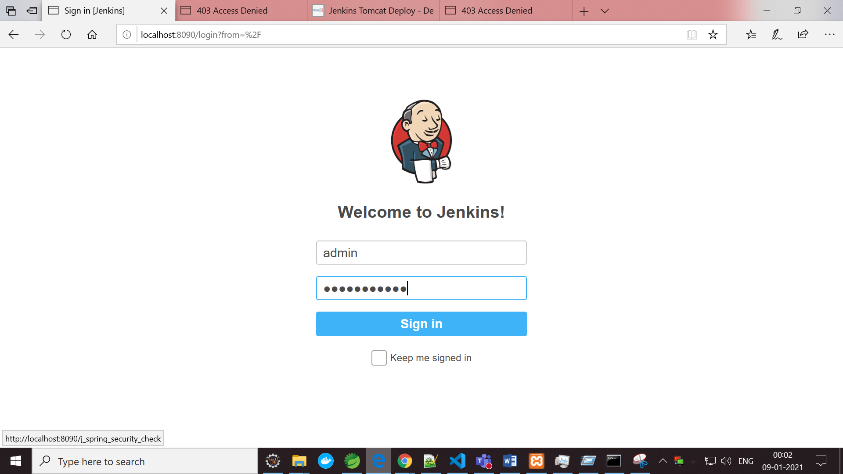

1. Installing Plugins:

Manage Jenkins -> Manage Plugins

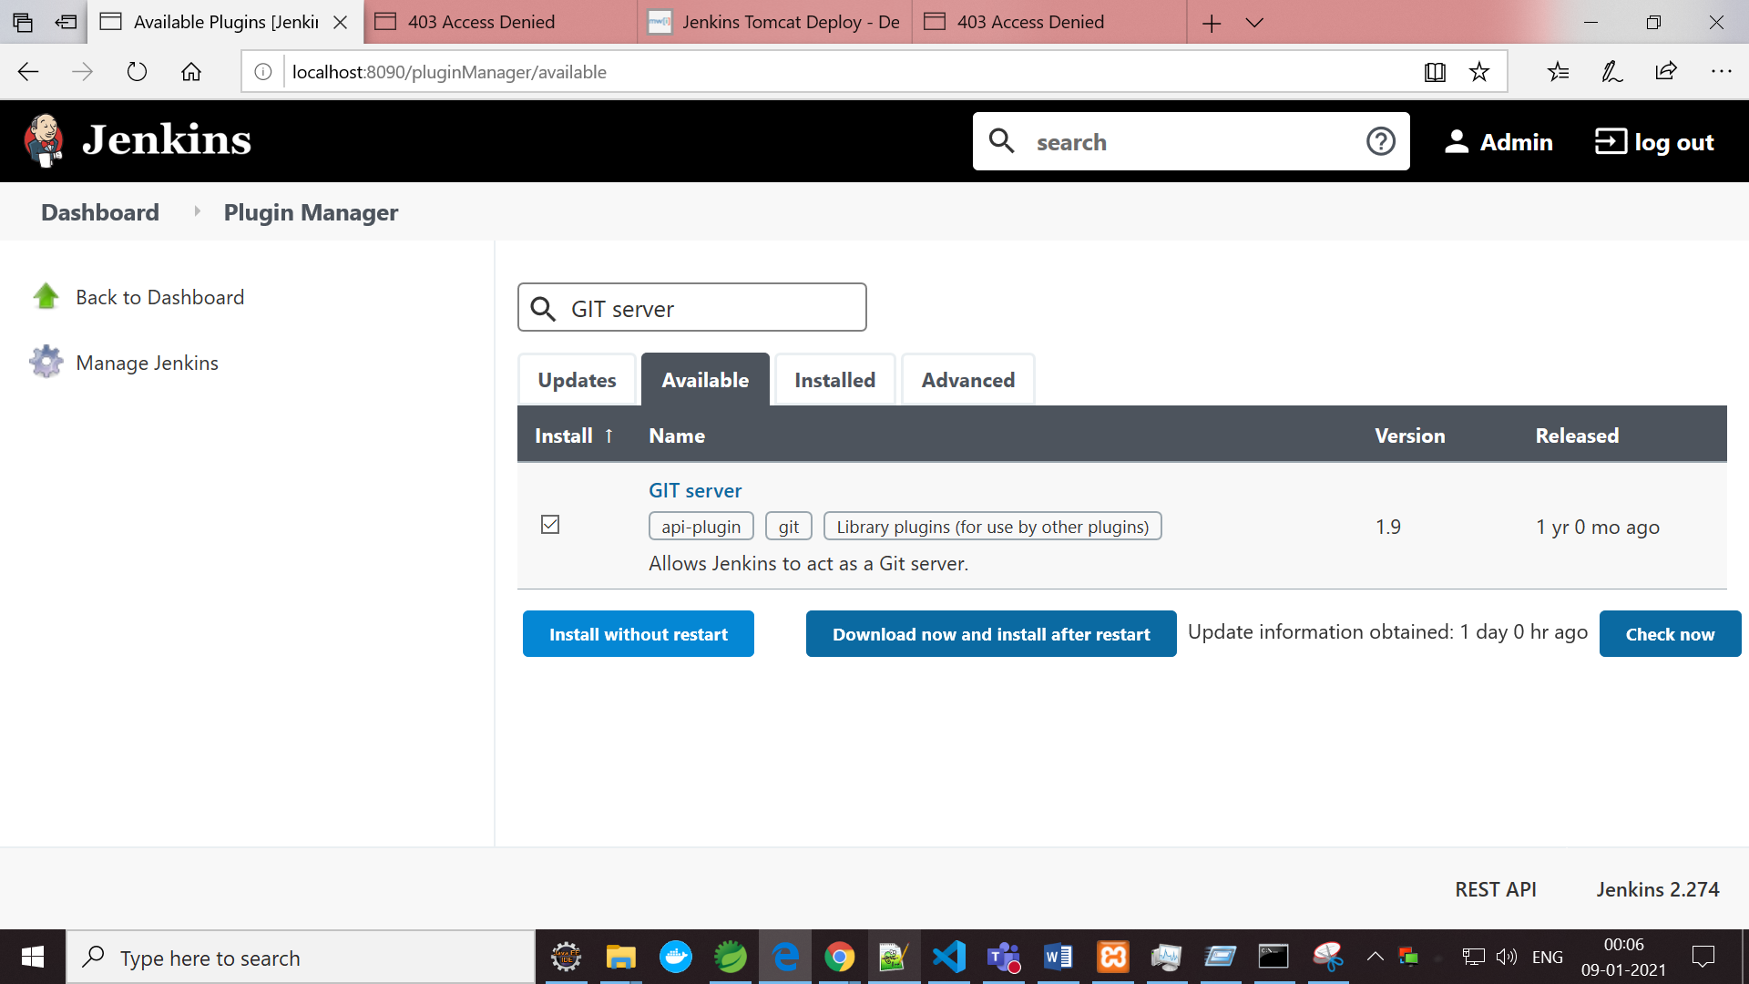

1. Install needed plugins: GIT, MAVEN, SSH, Junit, Gradle / Allure Report

Dashboard -> Manage Jenkins -> Manage plugins -> Available (type needed plugins) Check Installed tab whether it’s already installed or not.

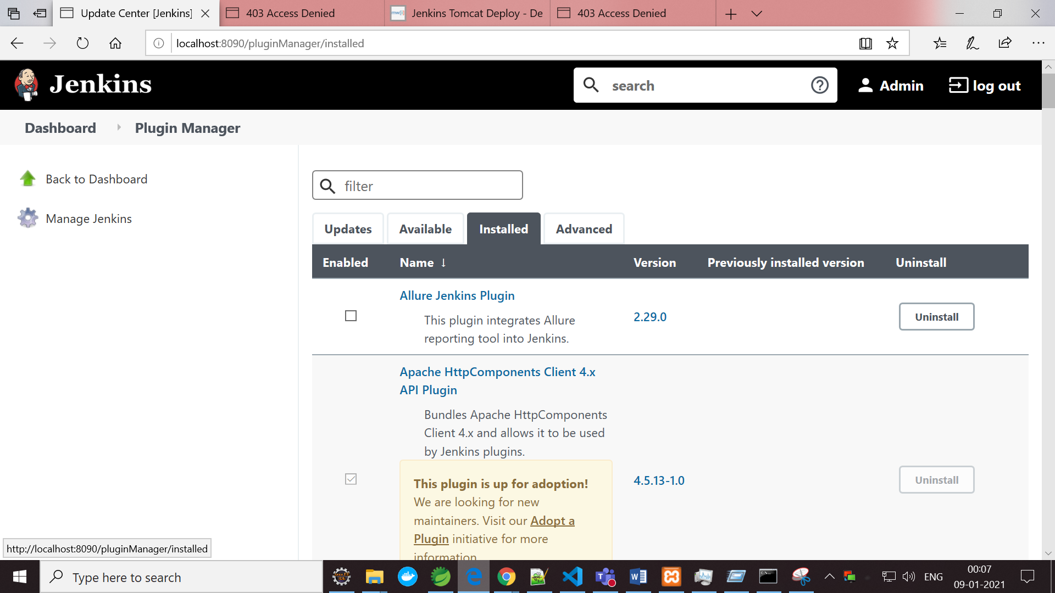

1. Add each configuration in Manage Jenkins -> Global Tool Configurations

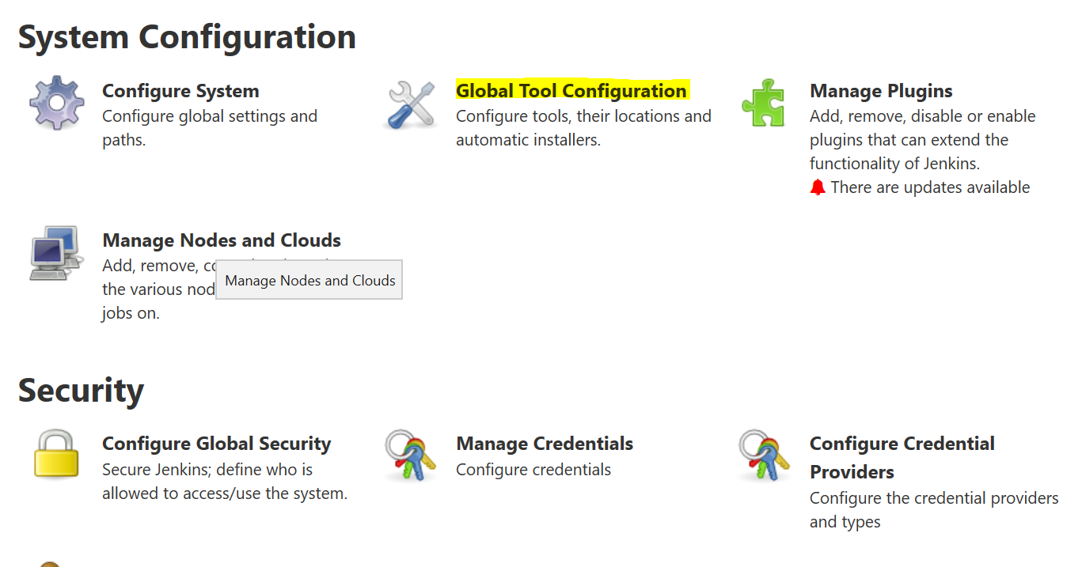

1. Set Git Configuration:

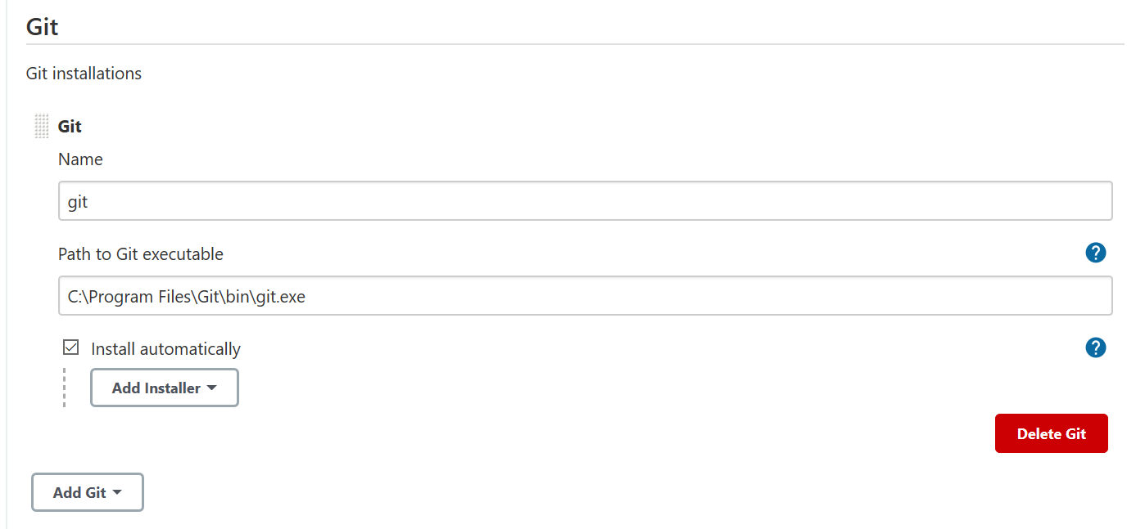

1. Set Maven Configuration:

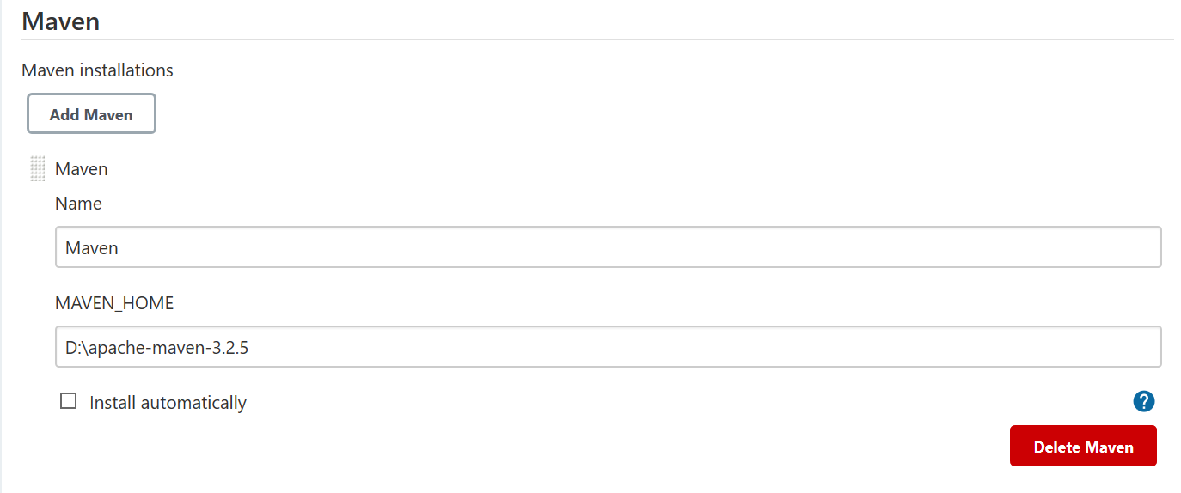

1. Set Gradle Configuration:

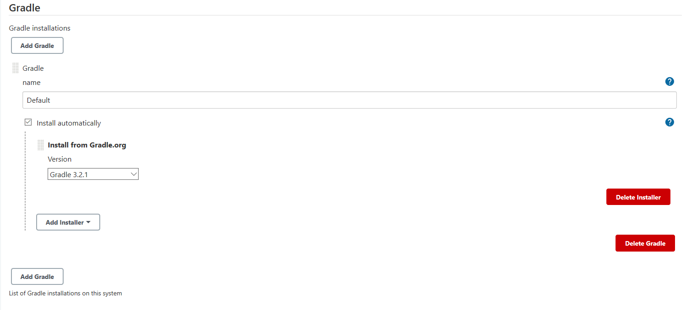

1. Click new item and create a job:

Dashboard -> New Item

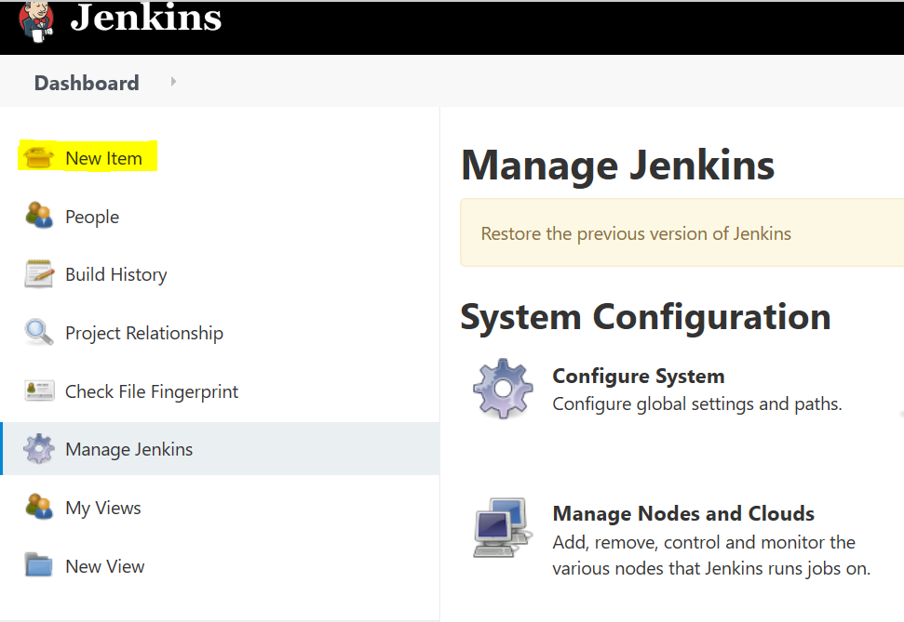

Enter job name -> select Maven Project -> click OK button. Now Job will be created

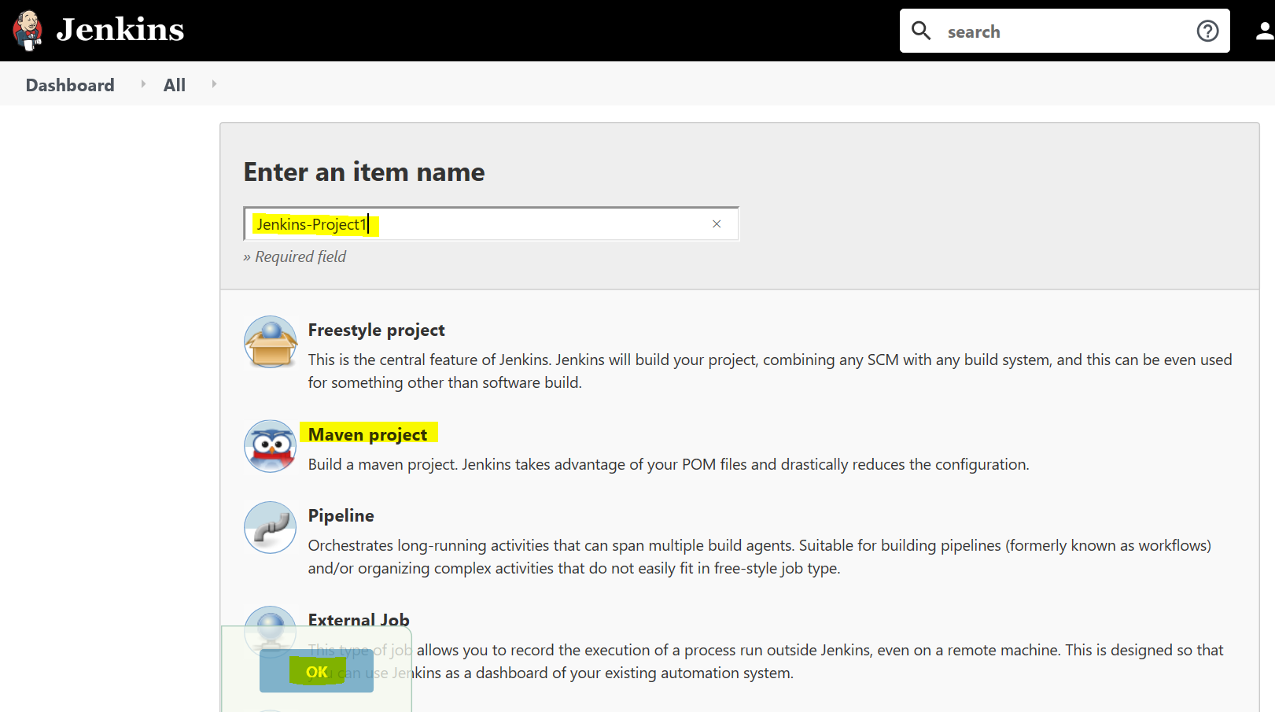

1. Now it will route to the job configure page:

Here, Add configure under **Source Code Management**

Add Git Repository URL and credentials and fill the branch or leave it blank

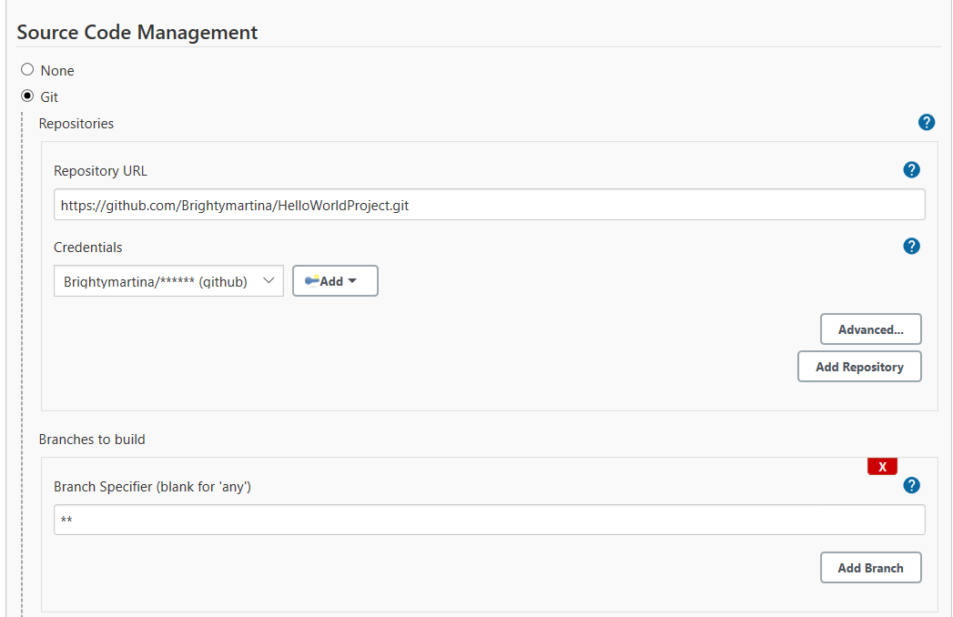

1. Add Build Configuration:

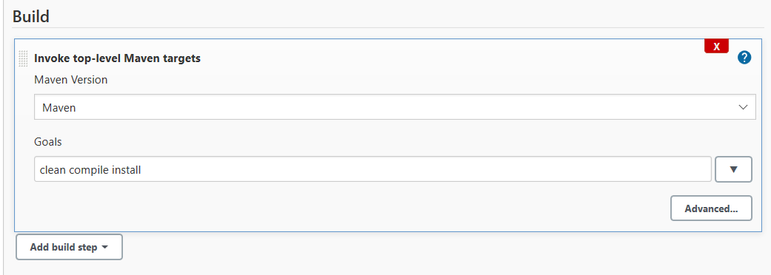

1. Add Post Build Action setup:

First setup is for Junit test result / report

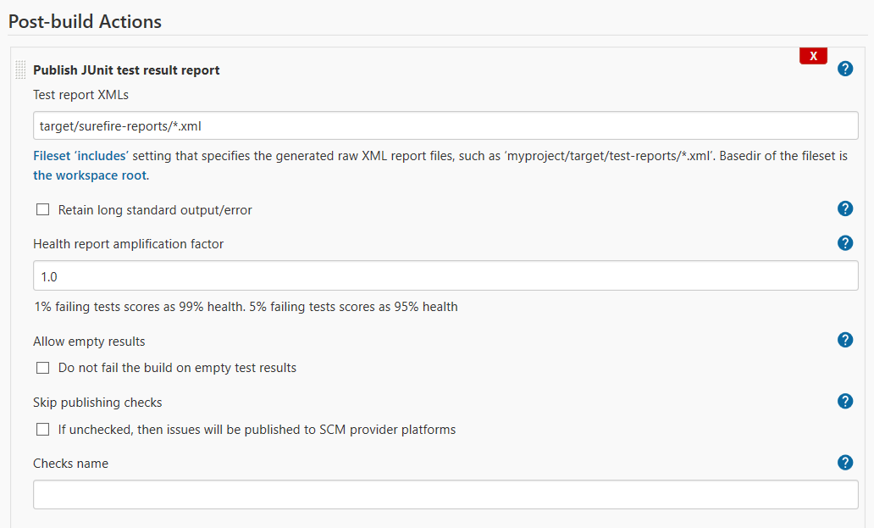

Secondly setup the Deploy WAR/EAR to a container:

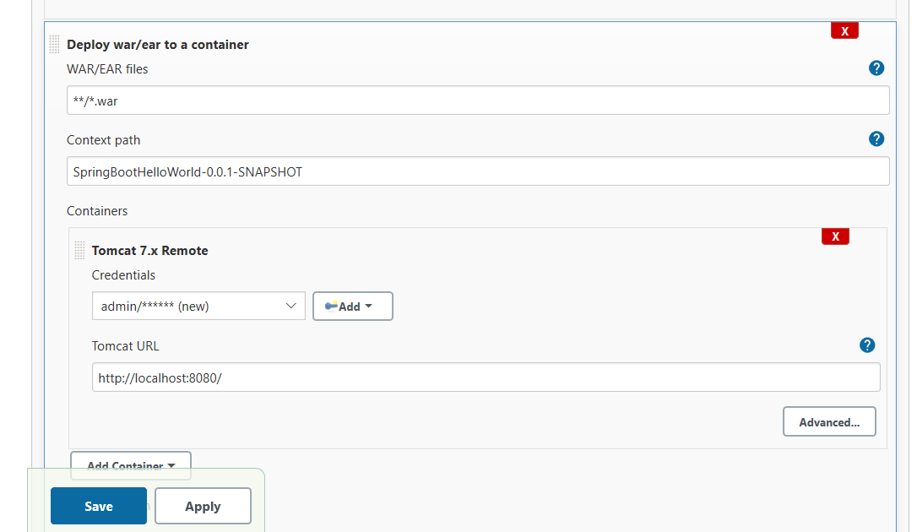

Then click Apply and save. Now we can see the below page,

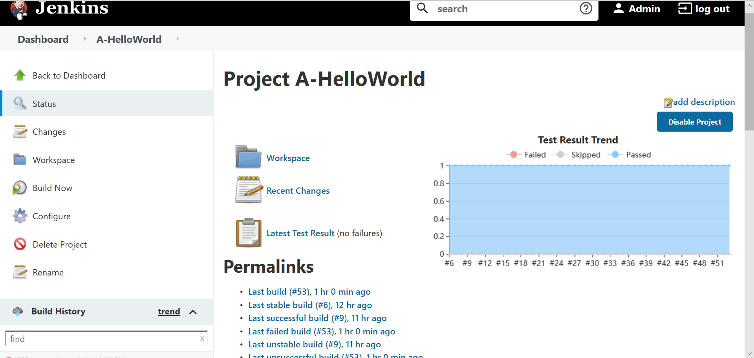

Click Build Now button for build the project

Click the Latest Test Result we can see Junit test cases result

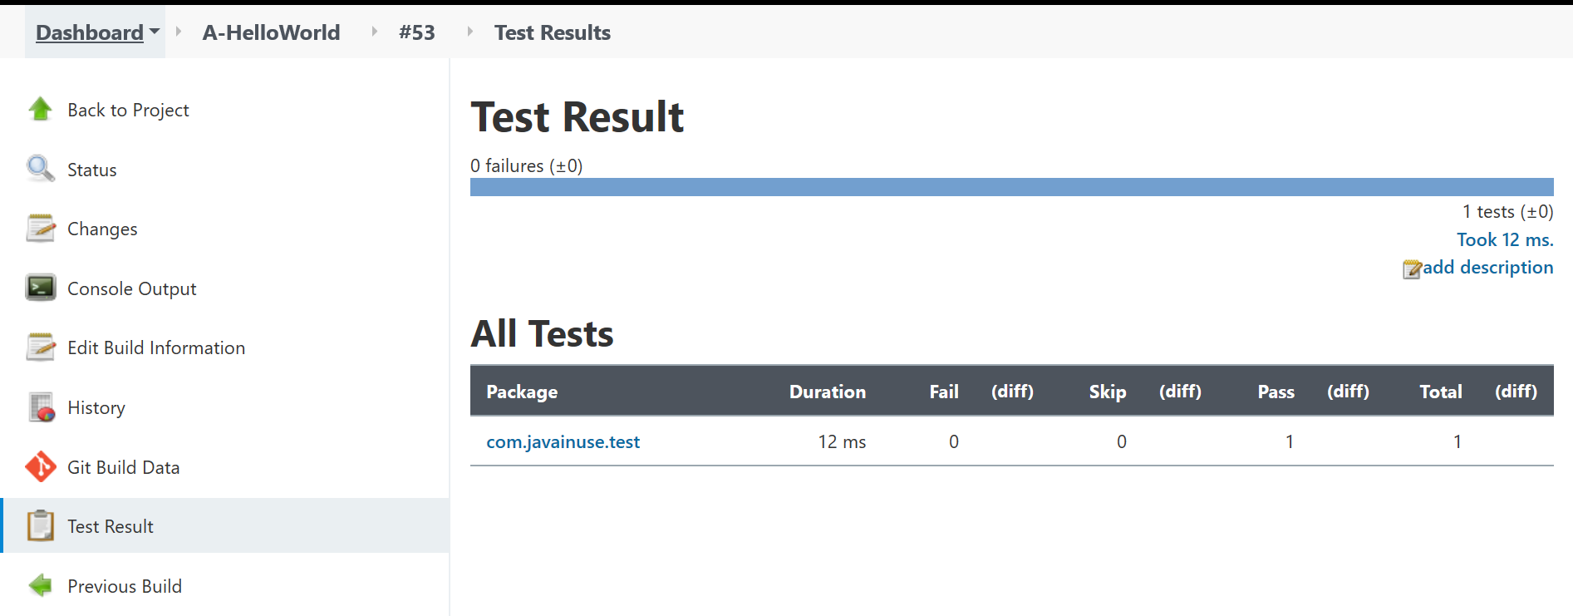

Git Repository path

<https://github.com/Brightymartina/HelloWorldProject>

